##### A

##### PROJECT PHASE I REPORT

ON

##### Kidney Microscopy Image Grading

###### ***Submitted by***

##### Simran Jamadar

##### Sneha Magdum

##### Sufiya Mulla

##### Rajlaxmi Mandavkar

***in partial fulfillment for the award of the degree of***

##### Bachelor of Technology

**IN**

Department of Computer Science and Engineering (AIML & Data Science)



# KOLHAPUR INSTITUTE OF TECHNOLOGY’S

# COLLEGE OF ENGINEERING (AUTONOMOUS), KOLHAPUR

2024-25

# KOLHAPUR INSTITUTE OF TECHNOLOGY’S

# COLLEGE OF ENGINEERING (AUTONOMOUS), KOLHAPUR

**CERTIFICATE**

This is to certify that the Seminar/ Project report entitled, **“Kidney Microscopy Image grading”** submitted by **“Simran Jamadar(DS15), Sneha Magdum(DS24), Sufiya Mulla(DS75), Rajlaxmi Mandavkar(DS77)”**, in partial fulfillment for the award of the degree of **“Bachelor of Technology”** in **“Computer Science and Engineering (Artificial Intelligence and Machine Learning and Data Science)”** at KIT’s College of Engineering, Kolhapur, Maharashtra, INDIA, is a record of his / her own work carried out under my / our supervision and guidance.

**SIGNATURE**

**DR. UMA P. GURAV**

**HEAD OF THE DEPARTMENT& SUPERVISOR**

Department of CSE (AIML & DS)

KIT’s College of Engineering, Kolhapur.

# KOLHAPUR INSTITUTE OF TECHNOLOGY’S

# COLLEGE OF ENGINEERING (AUTONOMOUS), KOLHAPUR

**DECLARATION**

I hereby declare that the Seminar/ Project entitled, **“Kidney Microscopy Image Grading”** submitted to KIT’s College of Engineering, Kolhapur, Maharashtra, INDIA in the partial fulfillment of the award of the Degree of **“Bachelor of Technology”** in **“Computer Science and Engineering (Artificial Intelligence and Machine Learning and Data Science)”**is a bonafide work carried out by me. The material contained in this Seminar/ Project has not been submitted to any University or Institution for the award of any degree.

**Simran Jamdar(DS15)**

**Sneha Magdum(DS24)**

**Sufiya Mulla(DS75)**

**Rajlaxmi Mandavkar(DS77)**

Place: KIT College, Kolhapur

Date: 29 Nov 2024

# KOLHAPUR INSTITUTE OF TECHNOLOGY’S

# COLLEGE OF ENGINEERING (AUTONOMOUS), KOLHAPUR

**ACKNOWLEDGEMENT**

I would like to express my deepest gratitude to our esteemed professor Dr. Uma P. Gurav, Head of the Department of Computer Science (AIML & DS) at Kolhapur Institute of Technology, Kolhapur. She has not only been a constant source of encouragement but has also guided me throughout this project, playing a crucial role in the successful completion of this project based learning activity. Her invaluable mentorship has been instrumental in helping me and my peers overcome the challenges encountered during this phase of our academic journey.I would also like to extend my heartfelt thanks to Dr. Mohan B. Vanarotti, the Director of Kolhapur Institute of Technology, for his support and leadership, which have been vital in fostering an environment conducive to learning and research.Lastly, I am deeply grateful to my parents, siblings, and friends for their unwavering support and motivation throughout my academic endeavors.

**Simran Jamdar(DS15)**

**Sneha Magdum(DS24)**

**Sufiya Mulla(DS75)**

**Rajlaxmi Mandavkar(DS77)**

Place: KIT College, Kolhapur

Date: 29 Nov 2024

**ABSTRACT**

This research paper focuses on detection of the grade of the cancerous kidney cells from microscopy images which depend on the experience of the specialist but there are times when the experts might not agree with their decision.There are ways in which a second opinion can be provided for the diagnosis of the image which is a computer-aided diagnosis, which helps to improve the reliability of the experts. Automatic and accurate classification of kidney microscopy images is very important in the medical field to identify malignant tumors and to classify them into grades. There are advanced convolutions neural network (CNN) based methods which have achieved great success in the classification of natural images,hence there is a lot of scope for these grading techniques in the field of biomedical image processing. In this paper we have designed a hybrid convolution neural network (HCNN) , which includes SE (Squeeze-and-excitation) block , Resnet block, and a resnet14 algorithm to gather called as SEresnet14. We have used the combination of these algorithms and blocks to classify and predict the grade of the kidney microscopy images into five classes G0, G1, G2, G3, and G4 (dataset used :KMC).The results shows that the model achieves accuracy between 98.87% and 99.34% for binary classification and 90.66% to 93.81% for multi-class classification. And the overall accuracy of the model is calculated is 0.87, the overall f1 score is 0.86, the overall precision is 0.86, the overall recall is 0.87, and overall jacard score is 0.77.

**TABLE OF CONTENTS**

**CHAPTER NO. TITLE PAGE NO.**

**Certificate**

**Declaration**

**Acknowledgement**

**Abstract**

**1. Introduction 1**

**2. Literature Review 3**

2.1 Gap Identification

2.2 Objectives

2.3 Problem Statement

**3. Study Area and Data Aquisition 6**

3.1 Dataset Collection

3.2 Image Samples

3.3 Grades Information

**4. Data Analysis And Methodology 8**

4.1 System Architecture

4.2 Methodology

4.2.1 Se Block

4.2.2 Resnet Block

4.2.3 Se-resnet Block

**5. Results And Discussion 13**

5.1 Classwise Result

5.2 Classification Report

**6. Conclusion And Future Scope 15**

**7. References 16**

**LIST OF TABLE**

|  |  |  |
| --- | --- | --- |
| **TABLE NO.** | **TITLE** | **PAGE NO.** |
| 2.1 | Literature Survey | 3 |
| 3.5 | Model Summary | 11 |
| 5.2 | Classification Report | 14 |

**LIST OF FIGURES**

|  |  |  |
| --- | --- | --- |
| **FIGURE NO.**  3.2 | **TITLE**  Image Samples | **PAGE NO.**  6 |
| 3.4 | Se_Resnet14 Architecture | 8 |
| 3.6 | Flowcharts | 12 |
| 5.1 | Class-Wise Results | 13 |

**LIST OF ABBREVATIONS**

|  |  |  |  |
| --- | --- | --- | --- |
| **S NO.** | **Abbrevation** | **Full form** | **PAGE NO.** |
| 1 | RCC | Renal Cell Carcinoma | 1 |
| 2 | SGD | Stochastic Gradient Descent | 13 |
| 3 | CNN | Convolutional Neural Network | 1 |
| 4 | ADAM | Adaptive Moment Estimation | 4 |
| 5 | RMSProp | Root Mean Square Propagation | 6 |
| 6 | SCR | Shared Channel Residual | 4 |
| 7 | BHCNet | Breast Histopathology Classification Network | 5 |
| 8 | ResNet | Residual Network | 5 |
| 9 | SE | Squeeze-and-Excitation | 5 |
| 10 | **G0, G1, G2, G3, G4** | Kidney Cancer Grades (Grade 0, Grade 1, Grade 2, Grade 3, Grade 4) | 9 |
| 11 | ReLU | Rectified Linear Unit | 8 |
| 12 | Conv2D | 2D Convolutional Layer | 7 |
| 13 | tf.keras | TensorFlow Keras | 7 |
| 14 | F1- score | harmonic mean of Precision and Recall | 10 |
| 15 | Support | Actual occurrences of each class in the dataset. | 9 |

**CHAPTER 1**

**INTRODUCTION**

Kidney cancer is currently considered as the leading cause of cancer and Renal Cell Carcinoma (RCC) is the most common type of cancer among all kidney cancer cases.Statistics indicate increasing new cases of kidney cancer worldwide and thus there is an essential need of a fast and precise cancer detection system to deal with the future challenges. Identification of the cancer stage plays crucial role. Grading of renal carcinoma is important for prognosis and is either required by reporting agencies or recommended by professional organizations such as the College of American Pathologists (CAP), International Collaboration on Cancer Reporting (ICCR), Royal College of Pathologists Australasia (RCPA), International Society of Urological Pathology (ISUP), Genitourinary Pathology Society (GUPS) and World Health Organization (WHO)[].Trends of kidney cancer cases worldwide are expected to increase persistently and this inspires the modification of the traditional diagnosis system to respond to future challenges.Te application of deep learning to analyze the histopathology images of kidney, breast, liver, prostate, colon, and other organs include a number of tasks such as nuclei detection and segmentation, characterization of sub-types of cancer, and grading. it’s more about the size of tumor, location, and how far cancer has been spread to the nearby lymph nodes, whereas the cancer grade describes how different or abnormal the cancerous cells look compared to normal healthy cells under the microscope. A fully automated and precise method of grading of kidney cancer from histopathology images is in high demand for identifying malignant tumors. The task of differentiating the cancerous cells and non cancerous cells is now automated, but the levels of the cancerous elements in the cell can be identified manually. Many laboratories still prefer to do this task manually due to accuracy issues. But Grading systems are available like Gleason [] and Fuhrman []. WHO / ISUP 4 tier grading system replaces Fuhrman grading system. Based on the single high power field showing the greatest degree of pleomorphism, rather than the predominant grade. Validated as a prognostic parameter for clear cell and papillary renal cell carcinoma (RCC), Value of grading in other RCCs is yet to be determined; in the meantime, the WHO recommends grading most RCCs for descriptive purposes and for future studies [].Deep Learning is a growing technology in the field of machine learning and it has got the attention of many researchers. The Convolution Neural Network (CNN) has achieved great success in large-scale image and video recognition. At present, automatic classification of pathological kidney cancer images based on convolution neural networks is still a very challenging problem.

The LiverNet[1] proposed CNN LiverNet model is among the first to establish a concrete methodology and results in the domain multi-grading HCC diagnosis. In BreastNet[4] the input dataset used is the BreakHis[2] dataset which includes 7909 images from 82 unknown patients situated in Brazil, here three algorithms, AlexNet,VGG14, and VGG19 are considered. To improve the algorithms as well as for optimization purposes the SGD, SGDR, ADAM, and RMSPro methods are used.Most of the previous work focused on transfer learning techniques and using pre-trained weights of the ImageNet dataset. The Renal Cell Carcinoma Grading Network (RCCGNet) from kidney histopathology images with a shared channel residual (SCR) block allows learning feature maps associated with different versions of input with two different but parallel paths. much more work like this is happening in the domain of histopathology images and pathology images. Our work aims to solve the problem with creation of a hybrid algorithm that can be implemented easily.for this purpose we need a light weight and highly accurate algorithm. for this we have combined the Resnet (residual block), resnet 14 algorithm and SE (Squeez and Excitation) block. the combination of these three algorithms works to find the most relevant features and helps to minimize the parameter size, also helps to overcome over-fitting problem. with this the accuracy is also very good and the model is very much precise. The model is inspired from BHCNet and SCCPNet. Both of these algorithm have implemented transfer learning for the task.An accurate and efficient end-to-end fully automated deep learning architecture is proposed for grading renal tumors from H &E stained kidney histopathology images. Our model also implements transfer learning with hybridization. The final task after the algorithm training and model creation is to make an application that can be used for the task. We used Flask framework with HTML, CSS as web development framework for development of the Web Application for the task. With Flask framework attachment of python and HTML becomes easy.

**CHAPTER 2**

**LITERATURE REVIEW**

The literature review highlights several studies that utilize deep learning models for the automated classification and grading of cancer from histopathological images. These models, primarily based on Convolutional Neural Networks (CNNs) and their variations, demonstrate significant improvements in accuracy and efficiency across different cancer types, including liver, breast, and kidney cancer.

Table 2.1 Literature Survey

|  |  |  |  |  |
| --- | --- | --- | --- | --- |
| **Sr. No** | **Author(s)** | **Title/Model** | **Dataset** | **Methodology and Findings** |
| **1** | Anirudh Ashok  Aatresh, Kumar Alabhya, Shyam Lal, Jyoti Kini, PU Prakash Saxena[1]. | LiverNet: efficient and robust deep learning model for automatic  diagnosis of sub-types of liver hepatocellular carcinoma cancer  from H and E stained liver histopathology images. | Multi-grading HCC | Convolutional Neural Networks (CNNs) for multi-class grading.  Demonstrated effectiveness in multi-grading using specific CNN architectures. |
| **2** | Mesut  To˘gaçar, Kutsal Baran Özkurt, Burhan Ergen, Zafer Cömert[2]. | BreastNet: A novel convolutional neural network model through  histopathological images for the diagnosis of breast cancer | BreakHis Dataset | Transfer learning with optimization techniques like SGD, ADAM, SGDR, RMSProp.Highlighted improvements in performance via optimizations on image datasets for breast cancer. |
| **3** | [Amit Kumar Chanchal](https://www.nature.com/articles/s41598-023-31275-7#auth-Amit_Kumar-Chanchal-Aff1),  [Shyam Lal](https://www.nature.com/articles/s41598-023-31275-7#auth-Shyam-Lal-Aff1),  [Ranjeet Kumar](https://www.nature.com/articles/s41598-023-31275-7#auth-Ranjeet-Kumar-Aff2),  [Jin Tae Kwak](https://www.nature.com/articles/s41598-023-31275-7#auth-Jin_Tae-Kwak-Aff3)  [Jyoti Kini](https://www.nature.com/articles/s41598-023-31275-7#auth-Jyoti-Kini-Aff4-Aff5)[3]. | A novel dataset and efficient deep learning framework for auto-  mated grading of renal cell carcinoma from kidney histopathology  Images. | Histopathology  Images. | Shared channel residual (SCR) block with parallel paths for input versions.Enhanced feature learning and classification accuracy. |
| **4** | Yun Jiang,  Li ChenID, Hai Zhang, Xiao Xiao[4]. | Breast cancer histopathological image classification using convolu-  tional neural networks with small SE-ResNet module | HistopathologyImages | A compact SE-ResNet module combines spatial and channel-wise feature extraction using Squeeze-and-Excitation and ResNet residual blocks, significantly enhancing accuracy in pathological image classification. |
| **5** | Sanghyun Woo ,  Jongchan Park, Joon-Young Lee, and In So Kweon[5]. | CBAM: Convolutional Block Attention Module | ImageNet-1K | The CBAM block focuses on the attention of the net-  work on the objects of interest. The CBAM consists of  a channel-wise attention block and spatial attention block  to focus on input feature map and network respectively. |

**2.1 GAP IDENTIFICATION**

A significant gap observed in the reviewed literature is the difficulty in balancing parameter size and model accuracy. While models with a larger number of parameters often achieve higher accuracy, they also encounter challenges such as prolonged training times and a higher risk of overfitting. This overfitting leads to a discrepancy between training and testing performance, where training accuracy is notably high, but testing accuracy remains comparatively low, limiting the model's generalizability and practical applicability.

**2.2 OBJECTIVE**

* Enhance Diagnostic Accuracy: Develop a reliable computer-aided diagnosis system for classifying kidney microscopy images to assist specialists in detecting cancer grades.
* Utilize Advanced Deep Learning Techniques: Implement a hybrid convolutional neural network (HCNN) model that combines Squeeze-and-Excitation (SE) blocks and ResNet architecture to improve feature extraction and classification performance.
* Classify Cancer Grades: Accurately classify kidney cancer cells into five distinct grades (G0, G1, G2, G3, G4) based on microscopy image analysis.
* Promote Second Opinions in Diagnosis: Provide a tool that enhances the second opinion process in cancer diagnosis, reducing variability in expert assessments and improving patient outcomes.

**2.3 PROBLEM STATEMENT**

To Design and Development of Deep learning Architecture for Kidney Microscopy Images Grading.

**CHAPTER 3**

**STUDY AREA AND DATA AQUISITION**

**3.1 DATASET COLLECTION**

The Dataset is collected by Department of Pathology,  Kasturba Medical College (KMC) Mangalore, Manipal Academy of Higher Education (MAHE), Manipal, Karnataka, India as a part of a clinical study during Oct 2020 to  Dec 2022.

**3.2 IMAGE SAMPLES**

The samples are of data collected by surgical biopsy of kidney tissue , stained with hematoxylin and eosin. the images are classified into Grade 0, Grade-1, Grade-2, Grade-3, Grade-4. starting Grade -0 is normal or non cancerous and eventually with every level the cancerous elements increase in the images. The Grade 4 is the highest level of cancerous elements, big and dense features can be seen in the images and the grades in between 0 and 4 the levels looks very much similar to each other. But still there is slight difference in the features of images.

|  |  |  |  |  |
| --- | --- | --- | --- | --- |
| Grade 0 | Grade 1 | Grade 2 | Grade 3 | Grade 4 |
| 0 | 1 | 3 | 3 | 4 |

Fig 3.2 Image samples

**3.3 GRADES INFORMATION**

1. Normal (Grade-0)

* Te cells of the proximal tubules have central nuclei and very acidophilic cytoplasm Cells are well arranged and are normal in number. A normal glomerulus structure

1. Grade-1

* Nucleoli are basoph. Nucleoli are not visible even 400× magnification Nucleoli are seen as eosinophilic at 400× magnification but not very prominent at 100× magnification. Morphology is very similar to normal nuclei.

1. Grade -2

* Nucleoli are seen as eosinophilic at 400× magnifcation but not very prominant at 100× magnification. Slightly irregular contour compared to normal nuclei. Grade-3 nuclei have a more irregular contour compared to normal nuclei

1. Grade- 3

* Nucleoli conspicuous and eosinophilic at 100× magnification. Clearly visible tumors were graded as grade-3

1. Grade-4

* Pronounced nuclear pleomorphism. Rhabdoid or sarcomatoid differentiation. Contains tumor giant cells

**CHAPTER 4**

**DATA ANALYSIS AND METHODOLOGY**

**4.1 SYSTEM ARCHITECURE**

The methodology followed is to pass the images through 3 diffenret blocks of code for feature extraction. The Architecture consits of Se block , resnet block and resnet14 block. The Se block is called from resnet block and resnet block is called in resnet14 block. The image is passes to the SE_resnet14 block then for feature extraction it is sent to resnet block and from resnet block for extracting more detailed and important features the process follows to SE block.The architecture is inspired by BHCNet [2] and SE (Squeeze-and-Excitation Networks) architecture [5].

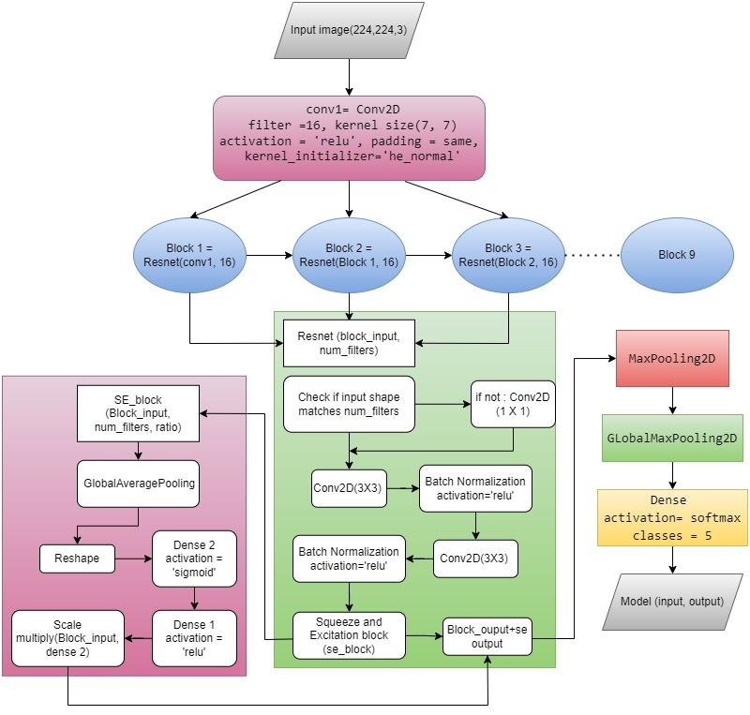

Fig. 3.4 SE_ResNet14 Architecture

**4.2 METHODOLOGY**

**4.2.1 SE block**

SE-block rectifies channel wise feature responses by explicitly modeling inter dependencies between channels. Re-calibrating the filter response involves two steps, squeeze and excitation.In the first step it uses global average pooling to squeeze the global spatial information into the channel descriptor. To make use of information that is aggregated in the squeeze operation we need to follow the second step which aim to capture channel wise dependencies. It uses fully connected neural network with two hidden layers to automatically learn the non-linear interaction and non-mutually-exclusive relationship between channels. The output of fully connected neural network can be defined as, The scaling factors obtained from the excitation operation used to modulate (or "gate") the original feature map activations. This is done by element wise multiplication, where each channel of the original feature map is multiplied by its corresponding scaling factor.

Firstly ‘block_input’ is passed through global average pooling layer (GlobalAveragePooling2D). It calculates average of each feature map in the input tensor across all spatial locations. It gives result with the shape of (1,1,num_filters). Now the output of global average pooling layer is reshaped using ‘Reshape’ layer. This reshaping is done to match the shape required for further operations. The output of reshaped layer is passed through dense layer(Dense) using RELU activation function. It reduces the number of channels in the input tensor. The output of first dense layer is passed to another dense layer with sigmoid activation function. It will show how much each feature map should be emphasized or suppressed. The output of second dense layer is element-wise multiplied with original input tensor which is ‘block input’. This operation adjusts the feature map based on theirimportant scores which is calculated in previous step. The scaled tensor is returned as the output of the SE block. Let X0 be the input of SE_ResNet module be the input of last convolution layer L.

so,

X=[ x1 ; x2 ; . . . . . . ..; xC] –(1.1)

Let K = [k1, k2, . . ., kC] –(1.2)

where K be the filter kernels of L, kC refers to the parameters of the C-th filter.

Then the output of L can be defined as,

O = [o1, o2, . . ., oC] –(1.3)

where, oC = kC * X

Here * denotes convolution, and K = [k1, k2, . . ., kC] (bias terms are omitted), while ki c is a 2D spatial kernel, and therefore represents a single channel of kc which acts on the corresponding channel of X.

**4.2.2 Resnet_block**

’resnet_block’ function defines a basic residual block used in ResNet architecture. In the first step we will check number of filters in input tensor matches the desired number of filters. If they don’t match then 1x1 convolution layer is applied which adjusts the number of filters. In next step using the same padding input tensor is passed through 3x3 convolution layer.It ensures that output has same spatial dimension as the input. Now Batch Normalisation is applied on previous output of the first convolution layer using ReLU activation function. Batch Normalisation is used to stabilize and accelerate the training process by normalizing the activation. Another 3x3 convolution layer is applied to the output of activation layer with same padding and filters. Again batch normalization is applied to second convolution layer.In further step the output of second batch normalization layer is passed through SE block. In this block the feature responses channel-wise relationships to enhance the representation power of block. The output of SE block is added to original input tensor. This connection allows for the flow of gradients during training of very deep networks. The sum of the input tensor and the output of the SE block is passed through a ReLU activation function. The ReLU-activated output tensor is returned as the output of the residual block.A convolution layer (‘Conv2D’) with 16 filters, a kernel size of (7,7), ReLU activation and same padding is applied to the input layer. Three sets of residual blocks that is ‘resnet_block’ are applied successively. Each set consists of three residual blocks with 16, 32, and 64 filters respectively.The output of each block is passed to the next block within the same set. Max pooling layers with a pool size of (2, 2) and a stride of (2, 2) are applied after the first, second, and third sets of residual blocks. These layers reduce the spatial dimensions of the feature maps by half. After this global average pooling layer is applied to pool the spatial dimensions of the feature maps and generate a fixed-length vector for each channel. The global average pooled features are fed through a dense layer with softmax activation to produce the final output. In this case, since it’s a classification task with 5 classes, the dense layer has 5 units and softmax activation. Finally, a tf.keras.models.Model is instantiated with the defined input and output layers.

**4.2.3 SE_Resnet14**

‘se_resnet14’ defines a simplified version of a ResNet14 architecture with SE (Squeeze-and-Excitation) blocks. First there is the input layer with a shape of (224,224,3), which is for RGB images. A convolution layer (‘Conv2D’) with 16 filters, a kernel size of (7,7), ReLU activation and same padding is applied to the input layer.Three sets of residual blocks that is ‘resnet_block’ are applied successively. Each set consists of three residual blocks with 16, 32, and 64 filters respectively. The output of each block is passed to the next block within the same set. Max pooling layers with a pool size of (2, 2) and a stride of (2, 2) are applied after the first, second, and third sets of residual blocks. These layers reduce the spatial dimensions of the feature maps by half.After this global average pooling layer is applied to pool the spatial dimensions of the feature maps and generate a fixed-length vector for each channel. The global average pooled features are fed through a dense layer with softmax activation to produce the final output. In this case, since it’s a classification task with 5 classes, the dense layer has 5 units and softmax activation. Finally, a model is instantiated with the defined input and output layers.

Table 3.5 Model summary

|  |  |
| --- | --- |
| Accuracy | 0.87 |
| Total Parameters | 303423 |
| Trainable Parameters | 302079 |
| Non- trainable Parameter | 1344 |

**FLOWCHARTS**

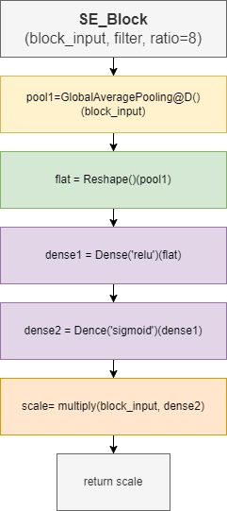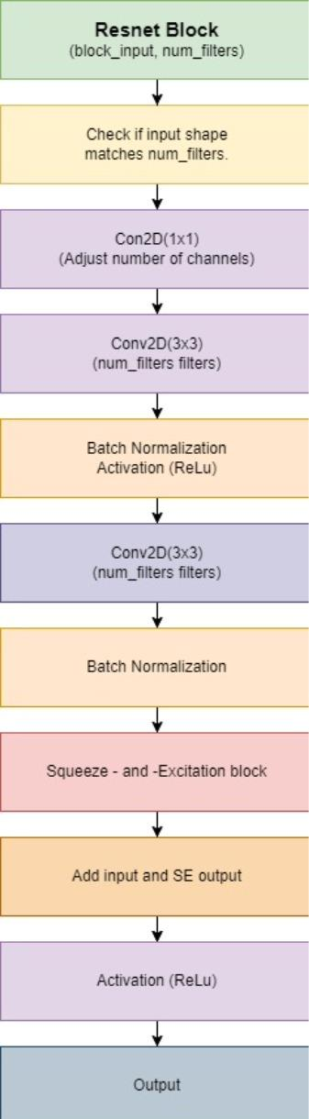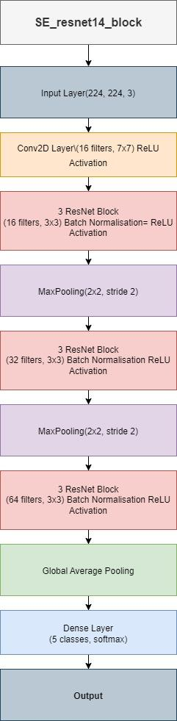

( a) (b) ( c)

Fig.3.6 Flowcharts- (a) Se resnet block, (b) Resnet block, ( c) Se resnet

**CHAPTER 5**

**RESULTS AND DISCUSSIONS**

After testing the model on testing dataset we got the results. And if we take the classification report of the test data according to the classification done by model on testing data we get the following report.

**5.1 CLASS-WISE RESULTS**

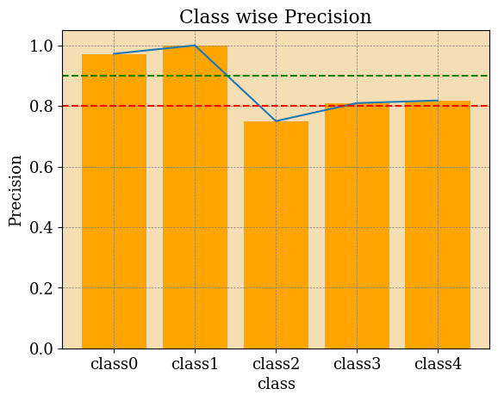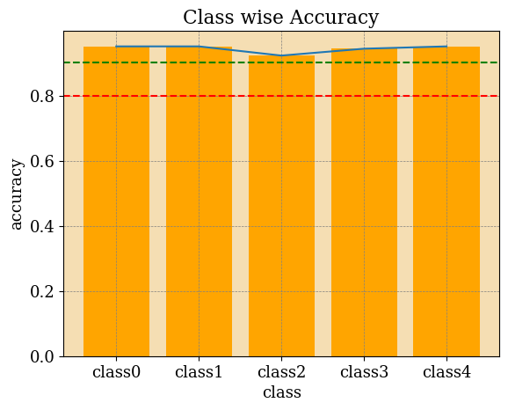

1. 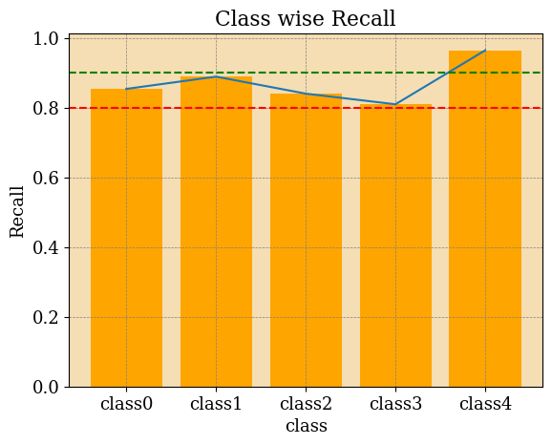Accuracy (b) Precision ( c)Recall

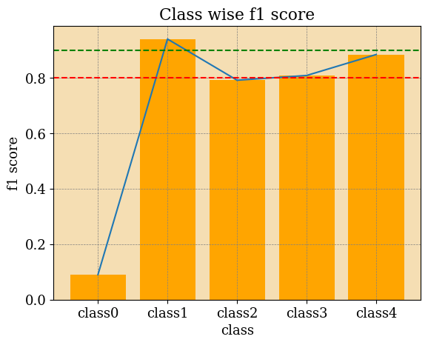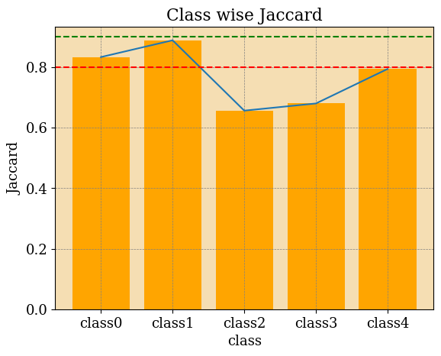(d) F1 score ( e) Jaccard

Fig.5.1. Class-wise Results (a) Accuracy , (b)Precision, ( c) Recall, (d) F1 score, ( e) Jaccard

**5.2 CLASSIFICATION REPORT**

Table 5.2 Classification report

|  |  |  |  |  |  |
| --- | --- | --- | --- | --- | --- |
| Class | Accuracy | F1 | Precision | Recall | Support |
| Class 0 | 0.95 | 0.90 | 0.97 | 0.85 | 41 |
| Class 1 | 0.95 | 0.94 | 1.0 | 0.88 | 27 |
| Class 2 | 0.92 | 0.79 | 0.75 | 0.84 | 25 |
| Class 3 | 0.94 | 0.80 | 0.80 | 0.80 | 21 |
| Class 4 | 0.94 | 0.88 | 0.81 | 0.96 | 28 |
| Total Accuracy | 0.87 |  |  |  | 142 |
| Macro avg |  | 0.87 | 0.87 | 0.87 | 142 |
| Weighted avg |  | 0.88 | 0.88 | 0.87 | 142 |

.

* The Accuracy is the Accuracy proportion of the algorithm done right classification. The Analysis of the Accuracy is as following chart.
* The precision is related to the positive classification the model has done, i.e 97% of the instances predicted as class 0 were actually class 0.
* The Recall is related to true positive classification the model has done. for instance let’s take class 1. 89% of the actual instances of class 1 were correctly predicted as class 1.
* The F1-score is the harmonic mean of precision and recall. For example, for class 2, the F1-score is 0.79, which is the harmonic mean of its precision and recall.
* Also the Support is the number of actual occurrences of each class in the dataset. The Macro avg is the average of the metrics calculated for each class, without considering class imbalance. At last the Weighted avg is the weighted average of the metrics calculated for each class, considering class imbalance.

**CHAPTER 6**

**CONCLUSION AND FUTURE SCOPE**

The work of classification can be intelligently automated by using  SE_Resnet14 algorithm. The algorithm showed improved accuracy of 87 % with the support of 142 and the reduced parameter size of 303423. The algorithm shows a good balance of accuracy and fewer parameters reduces the risk of over fitting.

The algorithm can be further developed. It can be improved by increasing accuracy and precise work. Similar technology can be used for other similar cancerous cells.

**CHAPTER 7**

**REFERENCES**

[1] LiverNet: efficient and robust deep learning model for automaticdiagnosis of sub-types of liver hepatocellular carcinoma cancerfrom H and E stained liver histopathology images by Anirudh AshokAatresh, Kumar Alabhya, Shyam Lal, Jyoti Kini, PU Prakash Saxena.

[2] BreastNet: A novel convolutional neural network model throughhistopathological images for the diagnosis of breast cancer by MesutTo˘gaçar, Kutsal Baran Özkurt, Burhan Ergen, Zafer Cömert

[3] A novel dataset and efficient deep learning framework for auto-mated grading of renal cell carcinoma from kidney histopathologyImages

[4] Breast cancer histopathological image classification using convolutional neural networks with small SE-ResNet module by Yun Jiang,Li ChenID, Hai Zhang, Xiao Xiao

[5] CBAM: Convolutional Block Attention Module by Sanghyun Woo ,Jongchan Park, Joon-Young Lee, and In So Kweon.

[6] Squeeze-and-Excitation Networks by Jie Hu, Li Shen, Samuel Albanie, Gang Sun, Enhua Wu.

[7] Deep Residual Learning for Image Recognition, Kaiming He Xiangyu Zhang Shaoqing Ren Jian Sun.

[8] VERY DEEP CONVOLUTIONAL NETWORKS FOR LARGE-SCALe IMAGE RECOGNITION Karen Simonyan and Andrew Zisserman, Visual Geometry Group, Department of Engineering Science, University of Oxford.

[9] ImageNet Classification with Deep Convolutional Neural Networks, Alex Krizhevsky, Ilya Sutskever, Geoffrey E. Hinton, University of Toronto.

[10] Review of deep learning: concepts, CNN architectures, challenges, applications, future directions Laith Alzubaidi1,5* , Jinglan Zhang1, Amjad J. Humaidi2, Ayad Al-Dujaili3, Ye Duan4, Omran Al-Shamma5, J. Santamaría6, Mohammed A. Fadhel7, Muthana Al-Amidie4 and Laith Farhan8

[11] An overview of gradient descent optimization algorithms, Sebastian Ruder, Insight Centre for Data Analytics, NUI Galway

[12] DeepLab: Semantic Image Segmentation with Deep Convolutional Nets, Atrous Convolution, and Fully Connected CRFs Liang-Chieh Chen, George Papandreou, Senior Member, IEEE, Iasonas Kokkinos, Member, IEEE, Kevin Murphy, and Alan L. Yuille, Fellow, IEEE

[13] He K, Zhang X, Ren S, Sun J. Identity mappings in deep residual networks. In: European conference on computer vision; 2016. p.630–645.

[14] Togacar, M. Ozkurt, K. B., Ergen, B., & Comert, Z. BreastNet: A novel convolutional neural network model through histopath logical images for the diagnosis of breast cancer. Phys. A Stat. Mech. Appl. 545, 123592 (2020).

[15] Nahid AA, Kong Y. Histopathological breast-image classification using local and frequency domains by convolutional neural network. Information. 2018;

[16] Guo Y, Dong H, Song F, Zhu C, Liu J. Breast Cancer Histology Image Classification Based on Deep Neural Networks. In: International Conference Image Analysis and Recognition. Springer; 2018. p. 827–836.

[17] G. Huang, Z. Liu, K. Q. Weinberger, and L. Maaten, “Densely connected convolutional networks,” in CVPR, 2017.

[18] Y. Ioannou, D. Robertson, R. Cipolla, and A. Criminisi, “Deep roots: Improving CNN efficiency with hierarchical filter groups,” in CVPR, 2017:

[19] T. Mensink, J. Verbeek, F. Perronnin, and G. Csurka. Metric Learning for Large Scale Image Classification: Generalizing to New Classes at Near-Zero Cost. In ECCV - European Conference on Computer Vision, Florence, Italy, October 2012.

[20] V. Nair and G. E. Hinton. Rectified linear units improve restricted boltzmann machines. In Proc. 27th International Conference on Machine Learning, 2010.

[21] Huang YL, Chen DR, Lin YC, et al. 3D Contouring for Breast Tumor in Sonography. arXiv preprint arXiv:190109407. 2019;

[22] Zeiler, M.D., Fergus, R.: Visualizing and understanding convolutional networks. In: Proc. of European Conf. on Computer Vision (ECCV). (2014).

[23] Ciresan, D. C., Meier, J., and Schmidhuber, J. Multicolumn deep neural networks for image classification. In CVPR, 2012.